**Kingdom’s Item Shop** *Test Plan Project*

Prepared by: Chelsea C.

Last Updated: 2024-11-26

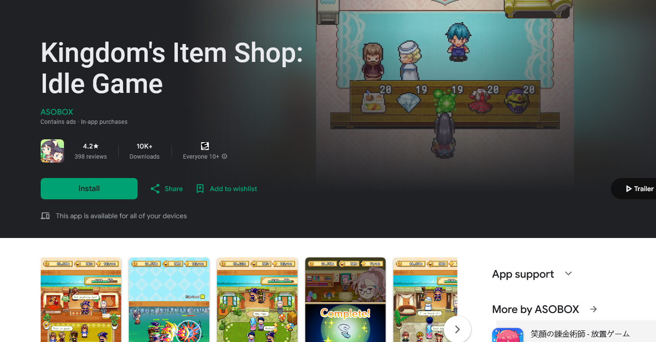

**Objective**

• I will be testing the overall functionality of core features and making sure the game is playable and free of bugs on my device* *(*Android 13 ver. 1.1.0 downloaded from Google Play).*

**Scope**

•In scope: Tutorial(s); main gameplay loop; user interface, art and audio.

•Out of scope: In-app purchases; localization testing

**Testing Approach**

•Manual Testing

•Exploratory Testing

**Resources and Tools**

•Chelsea C.as ***Solo-tester***

•Samsung Mobile Device and Wifi connection

•Trello as a brainstorming tool

•Excel for preparing Test Cases

•In-app bug reporting system (Google Forms)

**Test Schedule**

•3 day mini-project